SKYVIEW JUNIOR SCHOOL
TERM ONE HOLIDAY PACKAGE SET II 2020
CLASS : P . 1

SUBJECT : MATHEMATICS

Name _______________________________________

Read the Instructions
- This paper is made up of 2 sections. A and B
- Section A carries 40 marks and Section B carries 60 marks.
- Please show the working where necessary.

SECTION A: (40 MARKS)

- Count and write.
=

- Name the set below.

A set of __________________

- Add: 4 + 5 =

- Fill in the missing number.
8 , 9 , 10 , _______ , ______ , 13 , 14.
- Name the shape below.

__________________________

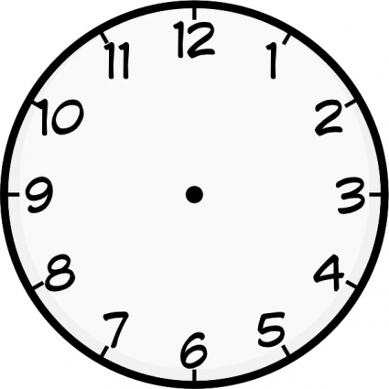
- Tell the time.

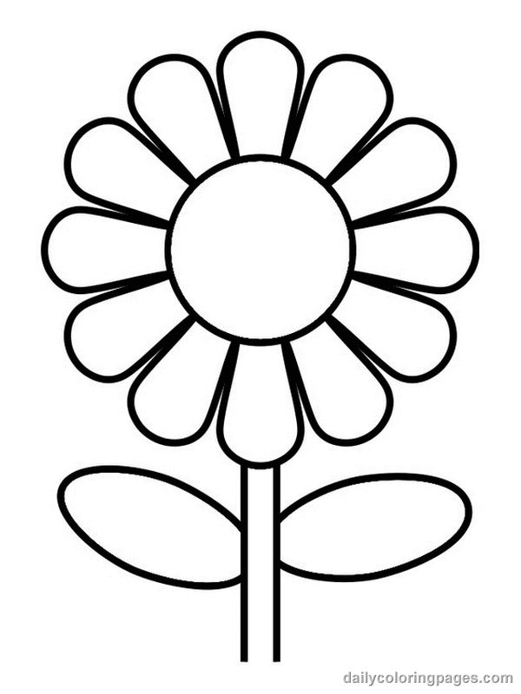
- Match correctly.

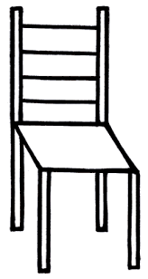

- Write the number name for 15.

- Write the missing days of the week.
Sunday , ________________ , Tuesday , Wednesday ,
_______________, Friday , Saturday.
- Write the number that comes before 9.
___________ , 9.
- Take away.
7 – 4 = _________________
- Circle the bigger number.
9 or 12
- Mary has four books. Peter has six books. How many books do they have altogether?

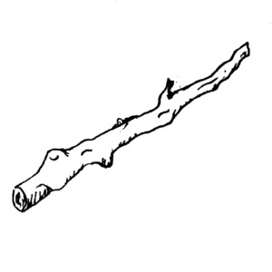
- Which stick is longer?
B
A

Stick _______________ is longer.

- Arrange these numbers starting from the smallest to the biggest.
8 , 6 , 4 , 10 , 2
_______________________________________________

- Draw the next pictures.

, , , ___________________________

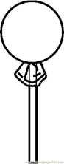
- Count and match.
Five


Three

SECTION B
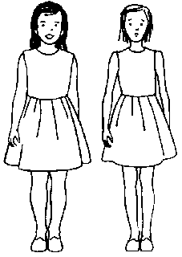
- Join these sets.

+ =

__________ + 2 = _______________

- Write the number name for;
6 = six
4 = ___________________________
7 = ___________________________

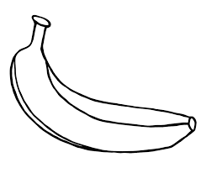
- Form new sets.

- Match correctly.
2 o’clock

8 o’clock

4 o’clock

- Name these shapes.
********************** END ***********************

